Assignment 2

PakWheels Car Marketplace

1. Inheritance
Inheritance allows a class to acquire the properties and behaviours of another, forming an "is-a" relationship. In this project, User serves as the base class for Buyer, Seller, Admin, and PremiumSeller. Every user type shares name and email fields and the ability to display their details, but each adds its own specialised behaviour for example, Buyer manages a favourites list while Seller manages car listings.
The same pattern applies to vehicles. Vehicle is the parent of Car and Bike, and Car is further extended by ElectricCar and LuxuryCar. Payment serves as the base for OnlinePayment and CashPayment. This hierarchy avoids duplication: shared logic lives once in the parent and every subclass inherits it automatically.
PremiumSeller extends Seller rather than User directly, which is a deliberate design choice it reuses the existing car listing logic and only adds bike listings and a badge, keeping the class focused and lean.

2. Polymorphism
Polymorphism lets the same method call produce different results depending on the actual object at runtime (overriding), or different results based on argument types at compile time (overloading).
Overriding is used throughout. calculateTax() is declared in Vehicle but overridden in Car, ElectricCar, LuxuryCar, and Bike each applying its own rate (10%, 5%, 18%, and 5% respectively). This means a Vehicle[] array can hold any mix of these types and calling v.calculateTax() on each one automatically invokes the correct version. The same applies to displayDetails() across all user types and processPayment() across payment types.
Overloading is used to provide flexible APIs. addFavorite() accepts either just a car, or a car plus a note. approveListing() accepts either just a car, or a car plus an admin comment. applyDiscount() accepts either just an amount, or an amount plus a custom rate. This keeps method names clean and intuitive.

3. Abstraction
Abstraction hides implementation details and exposes only what is necessary. Both User, Vehicle, and Payment are declared abstract, meaning they cannot be instantiated directly they exist purely to define a contract for their subclasses.
User forces every subclass to implement displayDetails() and displayDetails(boolean), ensuring every user type can present itself. Vehicle forces every subclass to implement calculateTax(), ensuring no vehicle can exist without a defined tax behaviour. Payment forces every subclass to implement processPayment(), ensuring no payment type can be created without defining how it processes.
This design means the rest of the codebase can work with User, Vehicle, or Payment references without knowing the concrete type the abstract class guarantees the method will exist.

4. Interfaces
Interfaces define capabilities that cut across the inheritance hierarchy. Four interfaces are used: Taxable, Discountable, Payable, and Searchable.
Taxable is implemented by both Vehicle and Payment completely unrelated in the hierarchy, but both need a calculateTax(double) method. Discountable is implemented by Car, Seller, PremiumSeller, and CashPayment, allowing all of them to be treated uniformly in a Discountable[] array. Searchable is implemented by Car and Bike, enabling a mixed Searchable[] array to be searched with a single loop. Payable is implemented by Payment and enforces the processPayment() contract.
The key design justification is that interfaces allow types with no common ancestor to share behaviour. A Car and a Seller are nothing alike in terms of inheritance, but both can offer a discount the interface captures that shared capability cleanly.

5. Generics
Generics allow classes and methods to work with any type while maintaining type safety at compile time. DataStore<T> is a reusable generic container that stores, searches, swaps, sorts, and displays items of any type used as both DataStore<Car> and DataStore<Bike> without any code duplication.
The static method findMax(T[] arr) uses a bounded type parameter <T extends Comparable<T>>, meaning it works on any array whose elements can be compared demonstrated with both Double[] prices and String[] brand names. countMatching(T[] arr, Checker<T> checker) accepts a lambda, making it a lightweight filtering utility. This removes the need for separate filter classes per type.

6. Inner Classes
Four inner class patterns are demonstrated inside Marketplace:
Member Inner Class (MemberInner) has direct access to the outer Marketplace instance's fields cars[], carCount, and marketplaceName without any parameters. It is used as a dashboard that reports live stats and finds the most expensive listing.
Static Nested Class (PromoBanner) does not need access to the outer instance. It holds a message and displays it independently, which is why it is static it belongs to the concept of a marketplace, not to any specific marketplace object.
Local Inner Class (PriceFilter inside filterByBudget) is defined and used entirely within a single method. It encapsulates the filtering and printing logic locally, keeping it out of the class-level scope where it would never be needed again.
Anonymous Inner Class is used in sortByPrice() to define a Comparator<Car> inline without creating a named class for a one-time-use comparison.

Design Summary
The project models a realistic vehicle marketplace using all six core OOP concepts in combination. Inheritance builds the type hierarchy. Abstraction enforces contracts. Polymorphism makes the code flexible at runtime. Interfaces connect unrelated types through shared capability. Generics make utilities reusable across types. Inner classes encapsulate behaviour at the right scope. Together they produce a codebase that is modular, extensible, and easy to reason about.
Code Snippets
- Interfaces
- Taxable:
public interface Taxable {
double calculateTax(double amount);
}
- Discountable:
public interface Discountable {
double applyDiscount(double amount);
}
- Payable:
public interface Payable {
void processPayment();
}
- Searchable:
public interface Searchable {
boolean matchesQuery(String query);
}
- Abstract
- User:
public abstract class User {
protected String name;
protected String email;
public User(String name, String email) {
this.name = name;
this.email = email;
}
public abstract void displayDetails();
public abstract void displayDetails(boolean showEmail);
public String getName() { return name; }
public String getEmail() { return email; }
}
- Vehicle:
public abstract class Vehicle implements Taxable {
protected String brand;
protected String model;
protected int year;
protected double price;
protected int mileage;
public Vehicle(String brand, String model, int year, double price, int mileage) {
this.brand = brand;
this.model = model;
this.year = year;
this.price = price;
this.mileage = mileage;
}
public abstract void calculateTax();
public double calculateTax(double amount) {
return amount * 0.10;
}
public void displayInfo() {
System.out.println(brand + " " + model + " (" + year + ") Price: Rs." + price + " Mileage: " + mileage + " km");
}
public void displayInfo(boolean showTax) {
displayInfo();
if (showTax) calculateTax();
}
public double getPrice() { return price; }
public String getBrand() { return brand; }
public String getModel() { return model; }
}
- Payment:
public abstract class Payment implements Discountable, Taxable, Payable {
protected double amount;
protected String method;
public Payment(double amount, String method) {
this.amount = amount;
this.method = method;
}
public abstract void processPayment();
public void processPayment(String confirmationCode) {
System.out.println("Processing " + amount + " via " + method + " Code: " + confirmationCode);
}
public double applyDiscount(double amt) {
return amt * 0.90;
}
public double calculateTax(double amt) {
return amt * 0.15;
}
}
- Classes
- Buyer:
public class Buyer extends User {
private Car[] favorites;
private int favoriteCount;
public Buyer(String name, String email) {
super(name, email);
favorites = new Car[5];
favoriteCount = 0;
}
public void addFavorite(Car car) {
if (favoriteCount < favorites.length) favorites[favoriteCount++] = car;
}
public void addFavorite(Car car, String note) {
addFavorite(car);
System.out.println("Note saved for " + car.getBrand() + ": " + note);
}
public void viewFavorites() {
System.out.println("--- " + name + "'s Favorites ---");
for (int i = 0; i < favoriteCount; i++) favorites[i].displayInfo();
}
public void displayDetails() {
System.out.println("Buyer | Name: " + name + " Email: " + email);
}
public void displayDetails(boolean showEmail) {
System.out.print("Buyer | Name: " + name);
if (showEmail) System.out.print(" Email: " + email);
System.out.println();
}
}

- Seller
public class Seller extends User implements Discountable {
protected Car[] listings;
protected int listingCount;
public Seller(String name, String email) {
super(name, email);
listings = new Car[10];
listingCount = 0;
}
public void addListing(Car car) {
if (listingCount < listings.length) listings[listingCount++] = car;
}
public void displayListings() {
System.out.println("--- " + name + "'s Listings ---");
for (int i = 0; i < listingCount; i++) listings[i].displayInfo();
}
public double applyDiscount(double amt) {
return amt * 0.92;
}
public double applyDiscount(double amt, double rate) {
return amt * (1 - rate);
}
public void displayDetails() {
System.out.println("Seller | Name: " + name + " Email: " + email
+ " Listings: " + listingCount);
}
public void displayDetails(boolean showEmail) {
System.out.print("Seller | Name: " + name);
if (showEmail) System.out.print(" Email: " + email);
System.out.println();
}
}
- Admin:
public class Admin extends User {
private static int adminCount = 0;
public Admin(String name, String email) {
super(name, email);
adminCount++;
}
public void approveListing(Car car) {
System.out.println("Admin " + name + " approved: " + car.getListingId());
}
public void approveListing(Car car, String comment) {
approveListing(car);
System.out.println(" Admin comment: " + comment);
}
public void displayDetails() {
System.out.println("Admin | Name: " + name + " Email: " + email);
}
public void displayDetails(boolean showEmail) {
System.out.print("Admin | Name: " + name);
if (showEmail) System.out.print(" Email: " + email);
System.out.println();
}
public static int getAdminCount() { return adminCount; }
}
- Car:
public class Car extends Vehicle implements Searchable, Discountable {
private final String listingId;
private static int carCount = 0;
protected String fuelType;
public Car(String brand, String model, int year, double price, int mileage, String fuelType) {
super(brand, model, year, price, mileage);
this.fuelType = fuelType;
listingId = "CAR" + (++carCount);
}
public void calculateTax() {
System.out.println("Car Tax (" + listingId + "): Rs." + (price * 0.10));
}
public void displayInfo() {
super.displayInfo();
System.out.println(" Fuel: " + fuelType + " ID: " + listingId);
}
public boolean matchesQuery(String query) {
String q = query.toLowerCase();
return brand.toLowerCase().contains(q) || model.toLowerCase().contains(q);
}
public double applyDiscount(double amt) {
return amt * 0.95;
}
public double applyDiscount(double amt, double rate) {
return amt * (1 - rate);
}
public String getListingId() { return listingId; }
public String getFuelType() { return fuelType; }
}
- Bike:
public class Bike extends Vehicle implements Searchable {
private final String listingId;
private static int bikeCount = 0;
private String type;
public Bike(String brand, String model, int year, double price, int mileage, String type) {
super(brand, model, year, price, mileage);
this.type = type;
listingId = "BIKE" + (++bikeCount);
}
public void calculateTax() {
System.out.println("Bike Tax (" + listingId + "): Rs." + (price * 0.05));
}
public void displayInfo() {
super.displayInfo();
System.out.println(" Type: " + type + " ID: " + listingId);
}
public boolean matchesQuery(String query) {
String q = query.toLowerCase();
return brand.toLowerCase().contains(q) || model.toLowerCase().contains(q);
}
public String getListingId() { return listingId; }
}
- Online Payment:
public class OnlinePayment extends Payment {
private String transactionId;
public OnlinePayment(double amount, String gateway) {
super(amount, gateway);
this.transactionId = "TXN" + System.currentTimeMillis();
}
public void processPayment() {
System.out.println("Online Payment of Rs." + amount + " via " + method
+ " [Transaction ID: " + transactionId + "]");
}
public double applyDiscount(double amt, double rate) {
return amt * (1 - rate);
}
}
- Cash Payment:
public class CashPayment extends Payment {
private String receivedBy;
public CashPayment(double amount, String receivedBy) {
super(amount, "Cash");
this.receivedBy = receivedBy;
}
public void processPayment() {
System.out.println("Cash Payment of Rs." + amount + " received by " + receivedBy);
}
public double applyDiscount(double amt) {
return amt * 0.97;
}
public double applyDiscount(double amt, double rate) {
return amt * (1 - rate);
}
}
- Premium Seller:
public class PremiumSeller extends Seller {
private Bike[] bikeListings;
private int bikeListingCount;
private String badge;
public PremiumSeller(String name, String email, String badge) {
super(name, email);
this.badge = badge;
bikeListings = new Bike[10];
bikeListingCount = 0;
}
public void addBikeListing(Bike bike) {
if (bikeListingCount < bikeListings.length) bikeListings[bikeListingCount++] = bike;
}
public void displayBikeListings() {
System.out.println("--- " + name + "'s Bike Listings ---");
for (int i = 0; i < bikeListingCount; i++) bikeListings[i].displayInfo();
}
public double applyDiscount(double amt) {
return amt * 0.85;
}
public void displayDetails() {
System.out.println("Premium Seller [" + badge + "] | Name: " + name
+ " Email: " + email + " Car Listings: " + listingCount
+ " Bike Listings: " + bikeListingCount);
}
public void displayDetails(boolean showEmail) {
System.out.print("Premium Seller [" + badge + "] | Name: " + name);
if (showEmail) System.out.print(" Email: " + email);
System.out.println();
}
}
- Electric Car:
public class ElectricCar extends Car {
private int batteryRangeKm;
private int chargePercent;
public ElectricCar(String brand, String model, int year, double price,
int mileage, int batteryRangeKm) {
super(brand, model, year, price, mileage, "Electric");
this.batteryRangeKm = batteryRangeKm;
this.chargePercent = 100;
}
public void calculateTax() {
System.out.println("Electric Car Tax (" + getListingId() + "): Rs."
+ (price * 0.05) + " (50% green discount applied)");
}
public void displayInfo() {
super.displayInfo();
System.out.println(" Battery Range: " + batteryRangeKm + " km Charge: "
+ chargePercent + "%");
}
public void charge() {
chargePercent = 100;
System.out.println(brand + " " + model + " fully charged.");
}
public int getBatteryRange() { return batteryRangeKm; }
}
- Luxury Car:
public class LuxuryCar extends Car {
private String[] premiumFeatures;
public LuxuryCar(String brand, String model, int year, double price,
int mileage, String fuelType, String[] premiumFeatures) {
super(brand, model, year, price, mileage, fuelType);
this.premiumFeatures = premiumFeatures;
}
public void calculateTax() {
System.out.println("Luxury Car Tax (" + getListingId() + "): Rs." + (price * 0.18) + " (luxury surcharge applied)");
}
public void displayInfo() {
super.displayInfo();
System.out.print(" Premium Features: ");
for (String f : premiumFeatures) System.out.print(f + " ");
System.out.println();
}
}
- Data Store:
import java.util.Arrays;
import java.util.Comparator;
public class DataStore<T> {
private T[] data;
private int size;
@SuppressWarnings("unchecked")
public DataStore(int capacity) {
data = (T[]) new Object[capacity];
size = 0;
}
public void add(T item) {
if (size < data.length) data[size++] = item;
}
public T search(T item) {
for (int i = 0; i < size; i++) {
if (data[i].equals(item)) {
System.out.println("Found: " + data[i]);
return data[i];
}
}
System.out.println("Item not found.");
return null;
}
public void swap(int i, int j) {
if (i < 0 || j < 0 || i >= size || j >= size) return;
T temp = data[i];
data[i] = data[j];
data[j] = temp;
System.out.println("Swapped positions " + i + " and " + j);
}
public void sort(Comparator<T> comp) {
Arrays.sort(data, 0, size, comp);
System.out.println("DataStore sorted.");
}
public void displayAll() {
System.out.println("--- DataStore contents (" + size + " items) ---");
for (int i = 0; i < size; i++) System.out.println(" [" + i + "] " + data[i]);
}
public static <T extends Comparable<T>> T findMax(T[] arr) {
if (arr == null || arr.length == 0) return null;
T max = arr[0];
for (T item : arr) if (item.compareTo(max) > 0) max = item;
return max;
}
public static <T> void printAll(T[] arr) {
System.out.println("=== printAll ===");
for (T item : arr) System.out.println(" " + item);
}
public static <T> int countMatching(T[] arr, Checker<T> checker) {
int count = 0;
for (T item : arr) if (checker.check(item)) count++;
return count;
}
public interface Checker<T> {
boolean check(T item);
}
}
- MarketPlace:
import java.util.Comparator;
public class Marketplace {
private Car[] cars;
private int carCount;
private String marketplaceName;
public Marketplace(String name) {
this.marketplaceName = name;
cars = new Car[20];
carCount = 0;
}
public void addCar(Car c) {
if (carCount < cars.length) cars[carCount++] = c;
}
public void displayAllCars() {
System.out.println("=== " + marketplaceName + " — All Listings ===");
for (int i = 0; i < carCount; i++) cars[i].displayInfo();
}
class MemberInner {
public void showStats() {
// Accesses outer instance fields directly
System.out.println("[Dashboard] " + marketplaceName
+ " currently has " + carCount + " cars listed.");
}
public void showMostExpensive() {
if (carCount == 0) { System.out.println("No cars listed."); return; }
Car best = cars[0];
for (int i = 1; i < carCount; i++)
if (cars[i].getPrice() > best.getPrice()) best = cars[i];
System.out.println("[Dashboard] Most expensive: ");
best.displayInfo();
}
}
static class PromoBanner {
private String message;
public PromoBanner(String message) { this.message = message; }
public void display() {
System.out.println("--------------------------------------");
System.out.println(" " + message);
System.out.println("--------------------------------------");
}
public static void displayWelcome() {
System.out.println("*** Welcome to the Car Marketplace! ***");
}
}
public void filterByBudget(double maxBudget) {
class PriceFilter {
public boolean isAffordable(Car car) {
return car.getPrice() <= maxBudget;
}
public void printResult(Car car) {
System.out.println(" [Within budget] ");
car.displayInfo();
}
}
PriceFilter filter = new PriceFilter();
System.out.println("Cars within Rs." + maxBudget + ":");
boolean found = false;
for (int i = 0; i < carCount; i++) {
if (filter.isAffordable(cars[i])) {
filter.printResult(cars[i]);
found = true;
}
}
if (!found) System.out.println(" No cars found within that budget.");
}
public void sortByPrice() {
Comparator<Car> priceComparator = new Comparator<Car>() {
public int compare(Car a, Car b) {
return Double.compare(a.getPrice(), b.getPrice());
}
};
for (int i = 1; i < carCount; i++) {
Car key = cars[i];
int j = i - 1;
while (j >= 0 && priceComparator.compare(cars[j], key) > 0) {
cars[j + 1] = cars[j];
j--;
}
cars[j + 1] = key;
}
System.out.println("Cars sorted by price (ascending).");
}
}
- Class Main:
public class Main {
public static void main(String[] args) {
// ── Create Users
Buyer buyer = new Buyer("Wajiha", "wajiha@example.com");
Seller seller = new Seller("Ali", "ali@example.com");
Admin admin = new Admin("Admin1", "admin@example.com");
PremiumSeller premiumSeller = new PremiumSeller("Sara", "sara@example.com", "Gold");
// ── Create Vehicles
Car corolla = new Car("Toyota", "Corolla", 2020, 3_000_000, 25_000, "Petrol");
Car civic = new Car("Honda", "Civic", 2022, 3_800_000, 10_000, "Petrol");
ElectricCar tesla = new ElectricCar("Tesla", "Model 3", 2023, 8_000_000, 5_000, 500);
LuxuryCar bmw = new LuxuryCar("BMW", "7 Series", 2023, 15_000_000.0, 2_000, "Petrol", new String[]{"Heated Seats", "Sunroof", "Massage Seats"});
Bike cd70 = new Bike("Honda", "CD70", 2021, 100_000, 5_000, "Standard");
Bike ybr = new Bike("Yamaha", "YBR 125", 2022, 250_000, 8_000, "Sport");
// ── Create Payments
Payment onlinePay = new OnlinePayment(3_000_000, "JazzCash");
Payment cashPay = new CashPayment(3_800_000, "Dealer Office");
System.out.println("----------------------------------------------------");
System.out.println(" PAKWHEELS — CAR MARKETPLACE DEMO ");
System.out.println("----------------------------------------------------");
// ── Registered Users
System.out.println("\n[ Registered Users ]");
buyer.displayDetails();
seller.displayDetails();
admin.displayDetails();
premiumSeller.displayDetails();
System.out.println("Total admins on platform: " + Admin.getAdminCount());
// ── Vehicle Listings
System.out.println("\n[ Available Vehicle Listings ]");
corolla.displayInfo();
civic.displayInfo();
tesla.displayInfo();
bmw.displayInfo();
cd70.displayInfo();
ybr.displayInfo();
// ── Seller Adds Listings
System.out.println("\n[ Sellers Adding Their Listings ]");
seller.addListing(corolla);
seller.addListing(civic);
premiumSeller.addListing(bmw);
premiumSeller.addBikeListing(cd70);
premiumSeller.addBikeListing(ybr);
seller.displayListings();
premiumSeller.displayListings();
premiumSeller.displayBikeListings();
// ── Admin Approves
System.out.println("\n[ Admin Approvals ]");
admin.approveListing(corolla, "All documents verified");
admin.approveListing(bmw, "Verified luxury listing — document check passed");
// ── Buyer Browses & Saves Favorites
System.out.println("\n[ Buyer Browsing & Adding Favourites ]");
buyer.addFavorite(corolla);
buyer.addFavorite(tesla, "Top choice for eco-friendly driving");
buyer.viewFavorites();
// ── Search Demo
System.out.println("\n[ Search Results for 'toyota' ]");
Searchable[] searchables = { corolla, civic, tesla, cd70, ybr };
for (Searchable s : searchables)
if (s.matchesQuery("toyota"))
System.out.println(" Match found: " + ((Vehicle) s).getBrand()
+ " " + ((Vehicle) s).getModel());
System.out.println("\n[ Search Results for 'yamaha' ]");
for (Searchable s : searchables)
if (s.matchesQuery("yamaha"))
System.out.println(" Match found: " + ((Vehicle) s).getBrand() + " " + ((Vehicle) s).getModel());
// ── Tax Calculations
System.out.println("\n[ Tax Calculations per Vehicle ]");
Vehicle[] vehicles = { corolla, tesla, bmw, cd70 };
for (Vehicle v : vehicles) v.calculateTax();
// ── Discount Comparison
System.out.println("\n[ Discount Applied on Rs.3,000,000 ]");
Discountable[] discountables = { corolla, seller, premiumSeller, (CashPayment) cashPay };
for (Discountable d : discountables)
System.out.printf(" %-18s → Rs.%,.0f%n",
d.getClass().getSimpleName(), d.applyDiscount(3_000_000));
// ── Marketplace & DataStore
System.out.println("\n[ Marketplace Loaded ]");
Marketplace market = new Marketplace("PakWheels Marketplace");
market.addCar(corolla);
market.addCar(civic);
market.addCar(tesla);
market.addCar(bmw);
Marketplace.PromoBanner.displayWelcome();
Marketplace.PromoBanner banner = new Marketplace.PromoBanner("SUMMER SALE — Up to 15% off all listings!");
banner.display();
Marketplace.MemberInner dashboard = market.new MemberInner();
dashboard.showStats();
dashboard.showMostExpensive();
System.out.println();
market.filterByBudget(4_000_000);
System.out.println("\n[ Sorted by Price ]");
market.sortByPrice();
market.displayAllCars();
// ── DataStore<Car>
System.out.println("\n[ DataStore — Car Inventory ]");
DataStore<Car> carStore = new DataStore<>(10);
carStore.add(corolla);
carStore.add(civic);
carStore.add(tesla);
carStore.add(bmw);
carStore.displayAll();
System.out.println("\nSearching for Corolla:");
carStore.search(corolla);
System.out.println("\nSwapping index 0 and 3:");
carStore.swap(0, 3);
carStore.displayAll();
System.out.println("\nSorted by price (ascending):");
carStore.sort((a, b) -> Double.compare(a.getPrice(), b.getPrice()));
carStore.displayAll();
System.out.println("\n[ DataStore — Bike Inventory ]");
DataStore<Bike> bikeStore = new DataStore<>(5);
bikeStore.add(cd70);
bikeStore.add(ybr);
bikeStore.displayAll();
bikeStore.swap(0, 1);
bikeStore.displayAll();
// ── Generic Utilities
System.out.println("\n[ Generic Utilities ]");
Double[] prices = { 3_000_000.0, 8_000_000.0, 15_000_000.0, 100_000.0 };
String[] brands = { "Toyota", "Honda", "BMW", "Tesla" };
System.out.println("Most expensive in array: Rs." + DataStore.findMax(prices));
System.out.println("Lexicographic max brand: " + DataStore.findMax(brands));
Car[] allCars = { corolla, civic, tesla, bmw };
int expensiveCount = DataStore.countMatching(allCars, car -> car.getPrice() > 5_000_000);
int electricCount = DataStore.countMatching(allCars, car -> car instanceof ElectricCar);
System.out.println("Cars priced above Rs.5,000,000: " + expensiveCount);
System.out.println("Electric cars in listing: " + electricCount);
DataStore.printAll(brands);
// ── Payment Processing
System.out.println("\n[ Payment Processing ]");
onlinePay.processPayment();
cashPay.processPayment();
System.out.println("\n[ Final Purchase — Corolla via EasyPaisa ]");
Payment finalPayment = new OnlinePayment(3_000_000, "EasyPaisa");
finalPayment.processPayment();
double discounted = finalPayment.applyDiscount(3_000_000);
double tax = finalPayment.calculateTax(discounted);
System.out.printf(" Original price : Rs.%,.0f%n", 3_000_000.0);
System.out.printf(" After discount : Rs.%,.0f%n", discounted);
System.out.printf(" Tax (15%%) : Rs.%,.0f%n", tax);
System.out.printf(" Final payable : Rs.%,.0f%n", discounted + tax);
System.out.println("\n---------------------------------------------------");
System.out.println(" Transaction complete. Drive safe! ");
System.out.println("-----------------------------------------------------");
}
}

Output: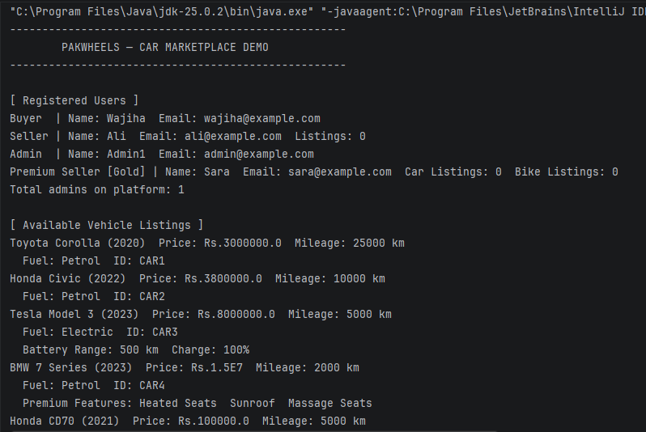 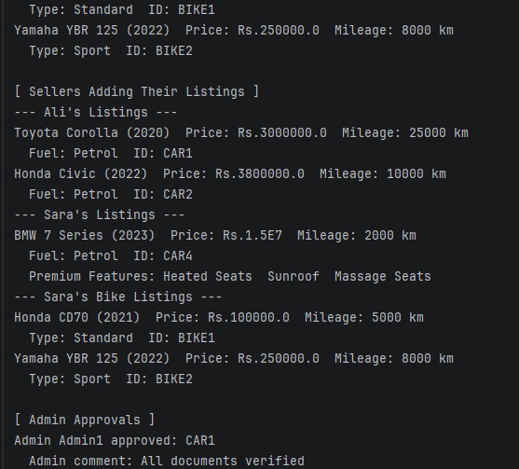
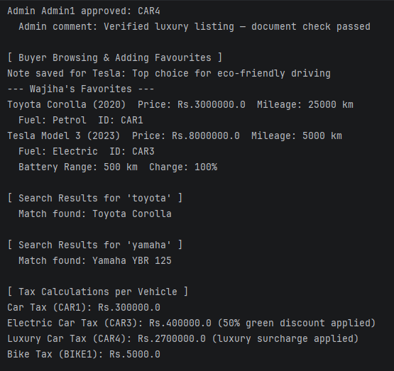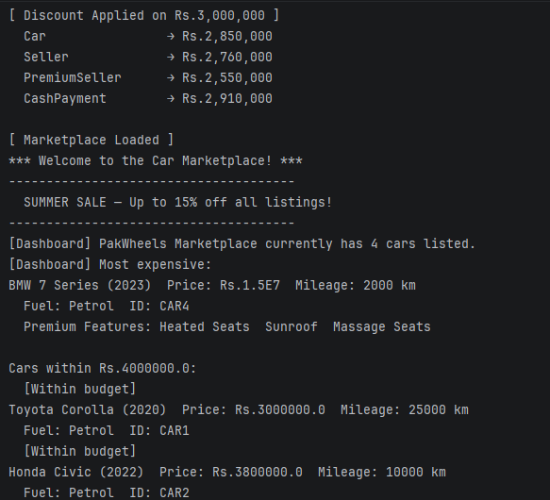
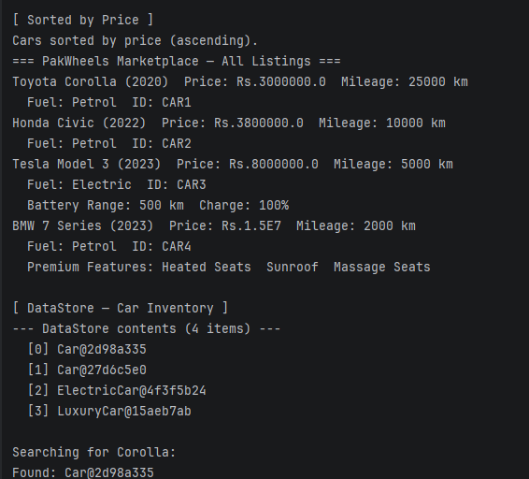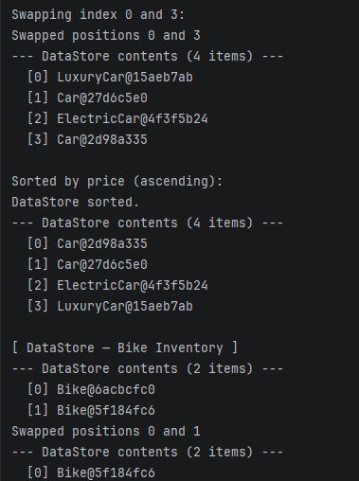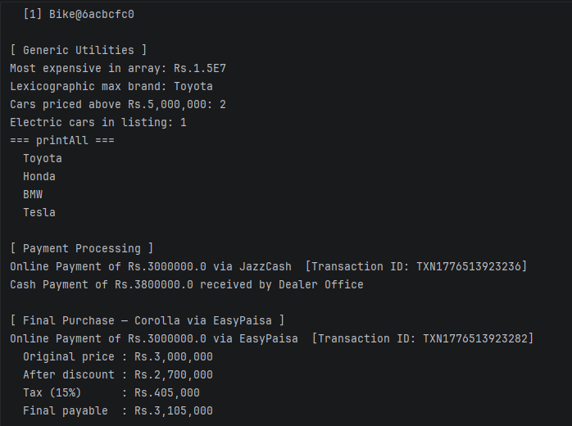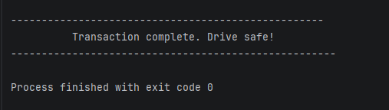

Class Buyer
- name : String
- email : String
- favorites : Car[]
+ Buyer(String, String): void
+ addFavorite (Car):void
+ viewFavorites ():void
+ sendMessage (String, String):String
+ getFavoriteCount ():int
Class Diagram:
Class Car
-brand: String
-model: String
-year: int
-price: double
-mileage: int
-listingId: final String

+Car(): void
+Car(String, String, int, double , int):void
+Car(Car):void
+getBrand():String
+getModel():String
+getYear():int
+getPrice():double
+getMileage():int
+getListingId():String
+setBrand(String):void
+setModel(String):void
+setYear(Int):void
+setPrice(Double):void
+setMileage(int):void
+updatePrice(double):void
+updateMileage(double):void
+displayInfo():void
+getCarCount():static int

Class Admin
- username: String
- role: String
+ Admin(String, String): void
+ approveListing(Car):void
+ removeListing(Car):void
+ displayAdminInfo():void
+ getAdminCount(): static int
Class Seller
- name: String
- email: String
- phone: String
- listings: Car[]
+ Seller(String, String, String): void
+ addListing (Car):void
+ removeListing ( String):void
+ displayListings ():void
+ getListingCount ():int

Class Message
- senderEmail: final String
- receiverEmail: final String
- content: String
-timestamp: final long
+ Message(String, String, String): void
+ editMessage(String):void
+ displayMessage():void
+ getContent(String, String):String
+ getTimestamp():long

Class Marketplace
- sellers: Seller[]
- buyers: Buyer[]
- cars: Car[]
+ Marketplace(): void
+ addSeller(Seller):void
+ addBuyer(Buyer):void
+ addCar(Car):String
+ displayAllCars():long
Class Listing
- car: final Car
- seller: Seller
- approved: boolean
-listingId: final String
+ Listing(Car, Seller): void
+ approve():void
+ reject():void
+ displayListing():void
+ isApproved():boolean
Class Payment
- paymentId: final String
- buyer: Buyer
- seller: Seller
-amount: double
-method: String
+ Payment(Buyer, Seller, double, String): void
+ processPayment():void
+ refund():void
+ displayPayment():void
+ getPaymentCount(): int

Class Review
- buyer : Buyer
- seller : Seller
- comment : String
- rating : int
- timestamp : final long
+ Review (Buyer, Seller, String, int): void
+ editReview (String, int):void
+ displayReview ():void
+ getRating ():int
+ getTimestamp (): long

Class SearchEngine
- cars: final Car[]
- carCount: int
+ SearchEngine(Car[], int): void
+ searchByPrice(double, double):void
+ searchByYear(int):void
+ searchByMileage(int):void
+searchByModel(String):void

